Project Report Template

INTRODUCTION:-

* 1. Overview:-

Retailng is a distribution process, in which all the activities involved in selling the merchanise directly to the final consumer (i.e. the one who intends to use the product) are included. It encompasses sale of goods and services from a points of purchase to the end user, who is goi g to use the product.

* 1. Purpose:-

Salesforce can be used to manage orders from retail stores and distributors, including tracking orders, processing payments, and managing inventory levels. This can help field sales teams ensure that orders are fulfilled quickly and accurately and that inventory levels are maintained at optimal levels.

2.Problem Definition and Design Thinking : -

2.1 Empathy Map:

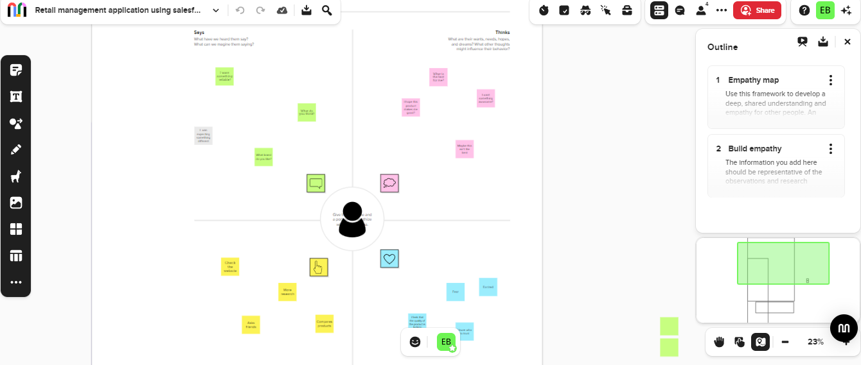

2.2 Ideation and Brainstorming map screenshot:-

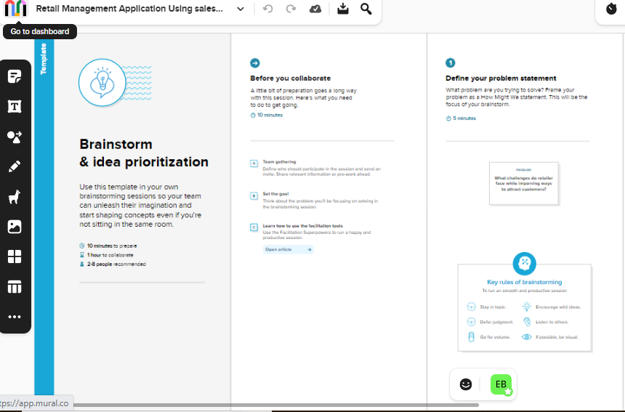

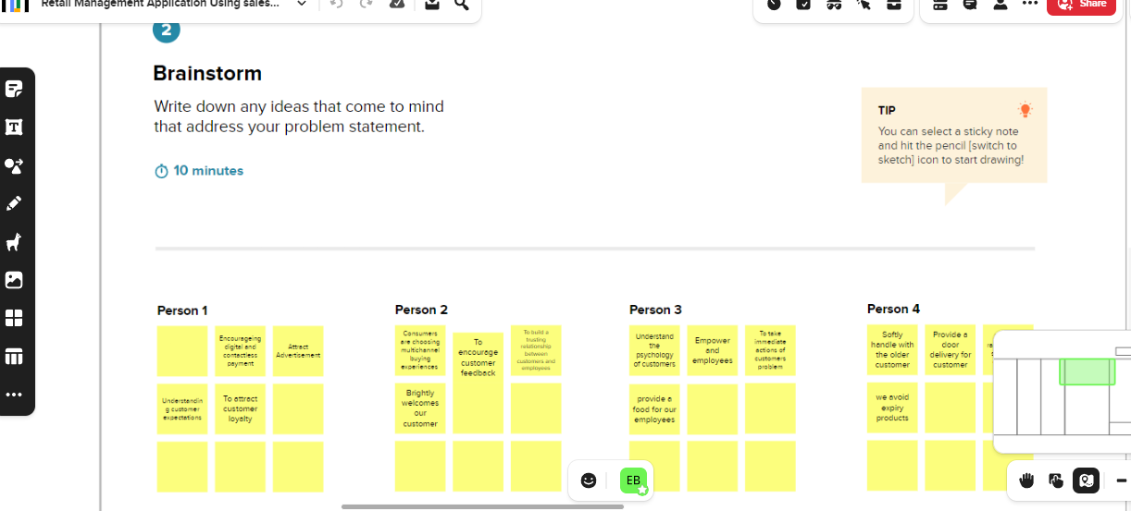

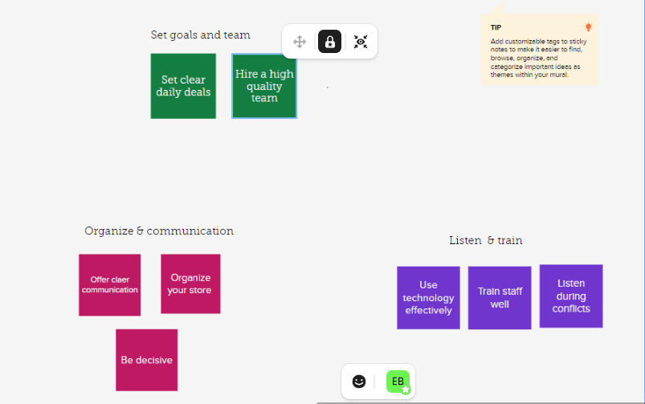

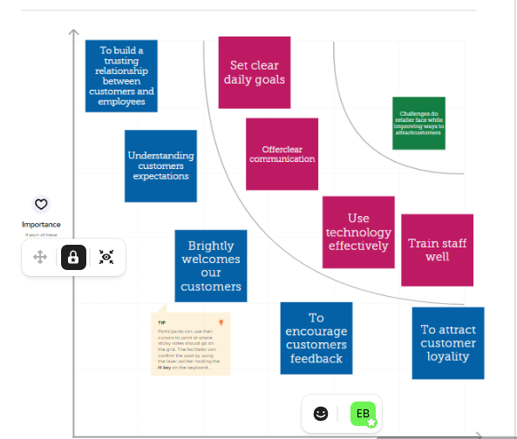

3.RESULT:-

3.1 Data Model:

|  |  |
| --- | --- |
| Object name | Fields in the object |
| Object-1 | Field label: Display/tracking  Data Type: Text |
| object-2 | Field label: Dispatched  Data Type: Checkbox |

3.2 Activity and Screenshot

Creating Developer Account

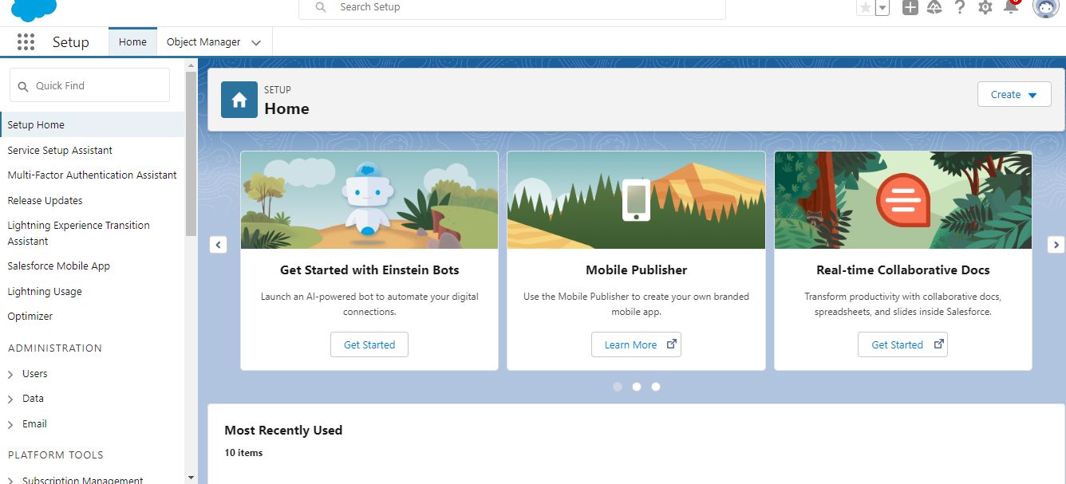

Object:

Creation of object Dispatch/tracking

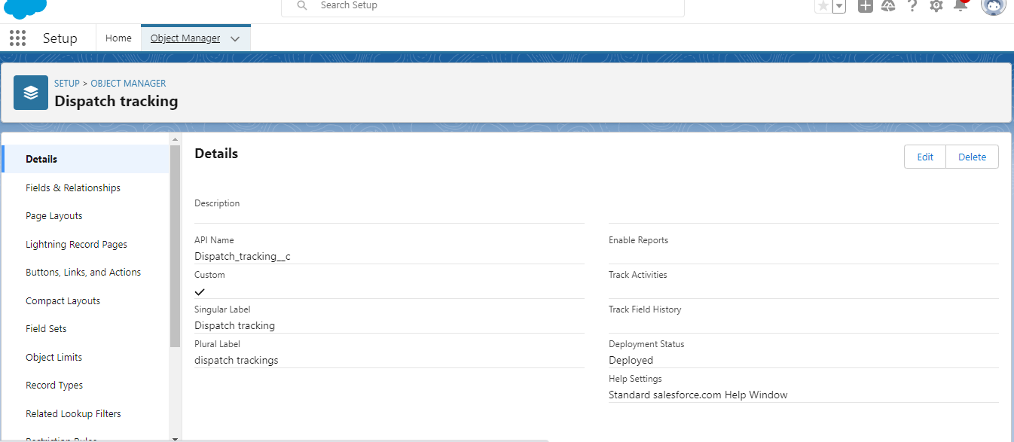

Fields available on Dispatch/tracking



Fields and Relations

Creation of Relationships between objects

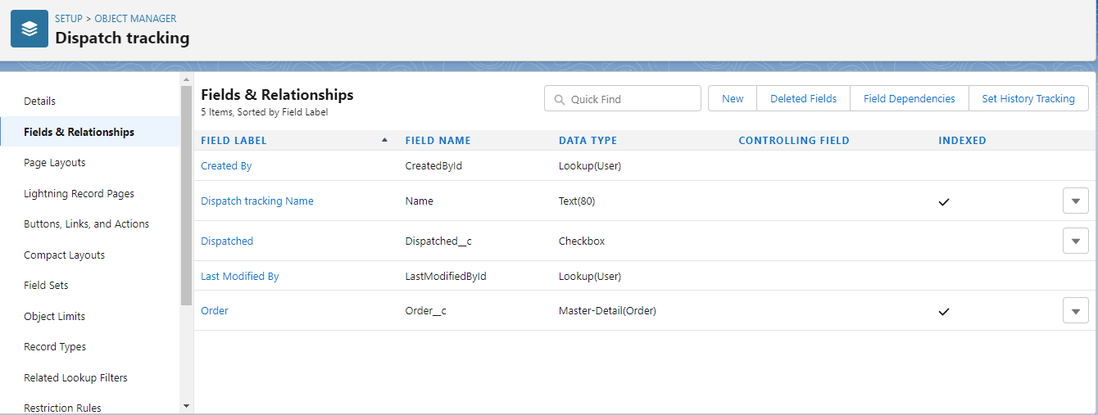

Creation of application

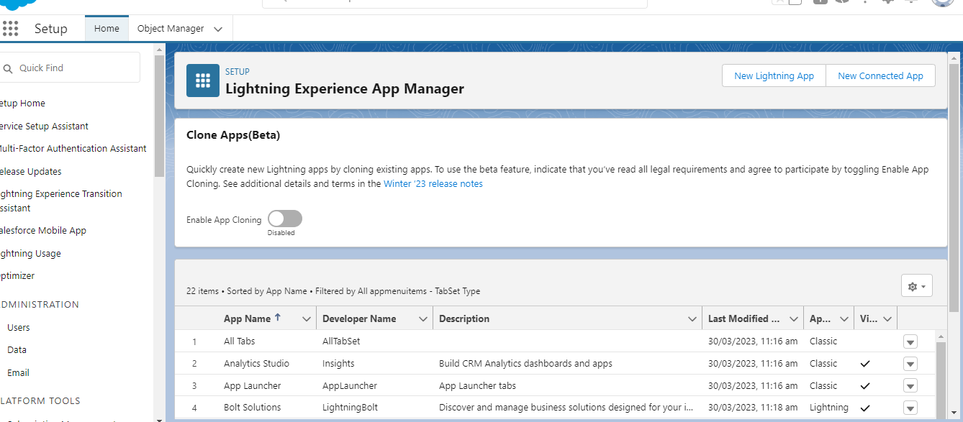

Creation of custom Tabs

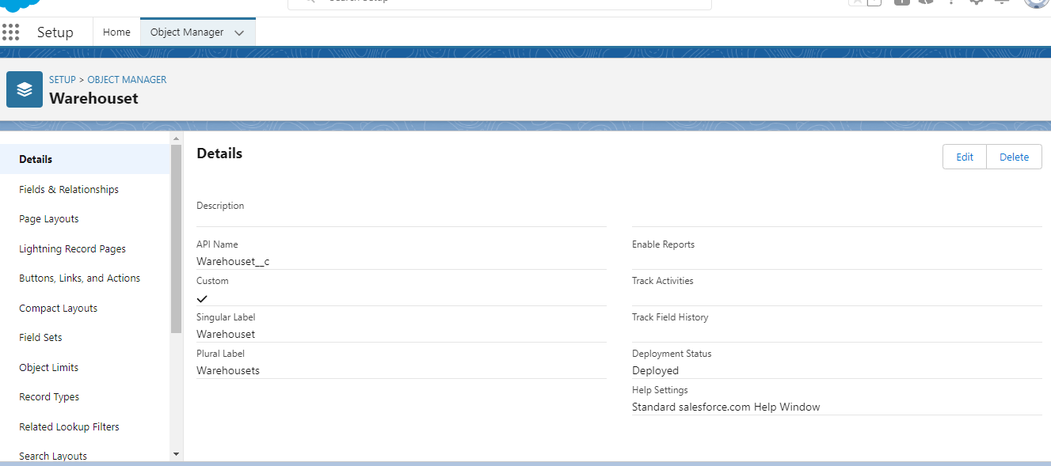

Creation of user

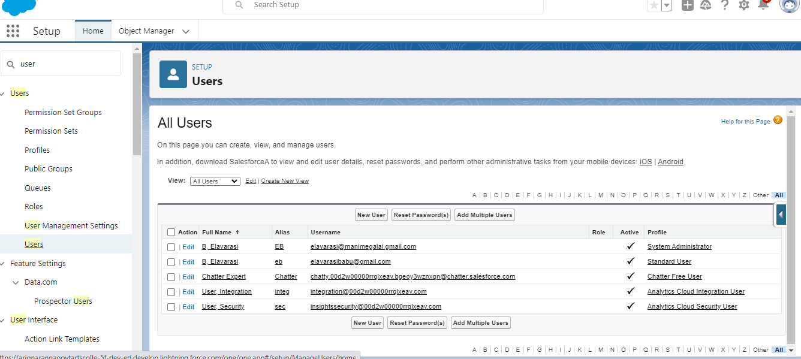

Profile

Creation on profile

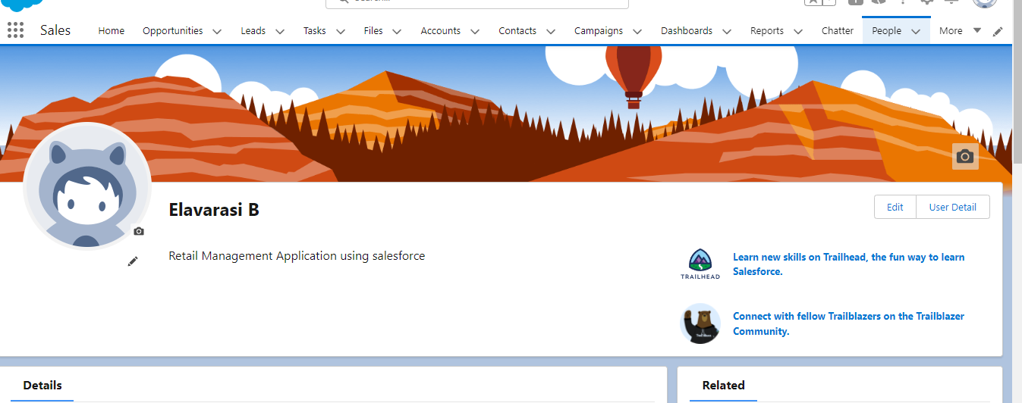

Creation of validation rule

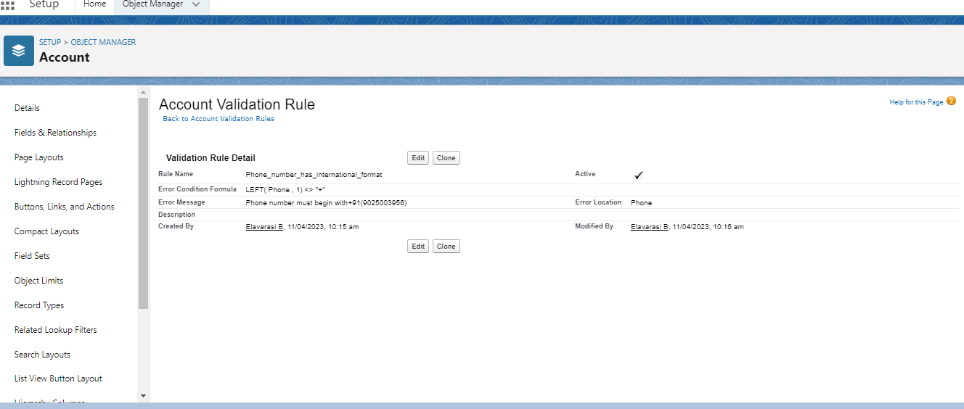

Creation of cross object

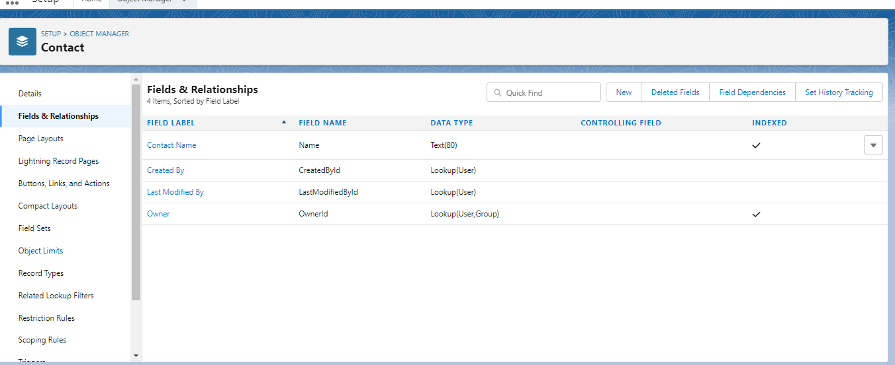

Reports:

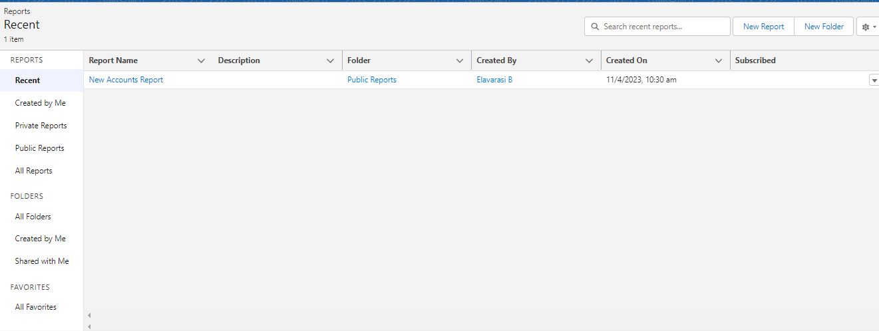

4.Trailhead Profile public URL

Team Lead- <https://trailblazer.me/id/ebabu9>

Team member 1- <https://trailblazer.me/id/elavs4>

Team member 2- <https://trailblazer.me/id/pparasu9>

Team member 3- <https://trailblazer.me/id/gomathigop>

5. **Benefits Or Advantages :**

The main advantages of retailers can be described as follows:

**1. Less Capital Requirement**

It does not require huge investment to start retail business. Retailers buy goods from wholesalers in small quantity and sell to ultimate customers. It does not need large space to store goods. So, retailing can be commenced with little investment.

**2. More Profit Margin**

There is fixed margin of profit for wholesalers. Generally they earn 3% to 8%  profit on sale. But there is no fixed margin for retailers, shopkeepers may fix profit margin up to 20% in some cases.

**3. Credit Facility**

Another benefit of retailers is that they get credit facility from wholesalers or dealers. But they sell products on cash which helps to maintain adequate liquidity in the business.

**4. Better Customer Relation**

Retailing is directly linked with the customers. Retailers can understand the interests, preferences and buying behavior of customers. It helps to build better customer relation and loyalty.

**5. No Liability**

In case of faulty or defective products, the manufacturer should replace the product. So, retailers do not need to bear the loss.

**Drawbacks Or Disadvantages:**

The main disadvantages of retailers can be described as follows:

**1. High Marketing Cost**

Retailers should make investment in decoration of shop and display of goods to attract more customers. So, it requires more marketing or advertising cost than wholesalers.

**2. Selling Skill Required**

It requires good selling skill to attract customers. Retailers should possess the art of good communication and convincing power to influence consumers.

**3. Very High Competition**

Another disadvantage of retailing is that there is tough competition in the market because several retailers sell similar types of products. So, it is difficult to remain in the competitive environment.

**4. No Economies Of Buying**

Retailers buy small volume of products from wholesalers. So, they miss the opportunity to enjoy he benefit of economies of buying.

APPLICATION:

* **Retail management** optimizes internal processes such as inventory management, offline and online storefronts, warehouse operations, payment and accounting, and human resources.
* **Retail management** improves overall company cohesion.
* **Retail store management** improves customer experience and boosts customer satisfaction.
* **Retail operation management** contributes to business growth.

**CONCLUSION:**

Whether you have a small shop for a big store, if you are running a retail business, then retail management is must to run it efficiently. Either you are a seller or a customer, everybody has 24 hours in a day and the time is very important for all.

FUTURE SCOPE:

The retail sector in the country is currently booming, providing plenty of career prospects for people with a passion for sales marketplaces, business diversification, campaigning, advertising, market research, and segmentation. With the continuous expansion of the retail industry, there is a growing demand for retail courses that will prepare students to cope with the tactics, procedures, and methods that will help them generate more sales and customer satisfaction.

Retail management has become one of the fastest-growing occupations in the industry as the economy has grown significantly. The retail industry in India is the most appealing and fastest-growing in the world, demanding an increase in competent expertise in this discipline.

It intends to create a new generation of international-caliber smart retail experts by providing them with global best practices.